

Ruth Vacas Miñana

1DAM

Sistemas informaticos

ACTIVITIES1_2

Configuration of virtual machines

Review the 4th section in UNIT4 documentation for reference to perform this activity.

1. Update your VirtualBox application installing the last Extension Pack
2. Add a new Virtual Machine having the Ubuntu Desktop Operating System as a guest.
3. Install VirtualBox Guest Additions
4. Share a folder between the Host and the Virtual Machine. Check that you are able to read files on that folder from both Operating Systems.

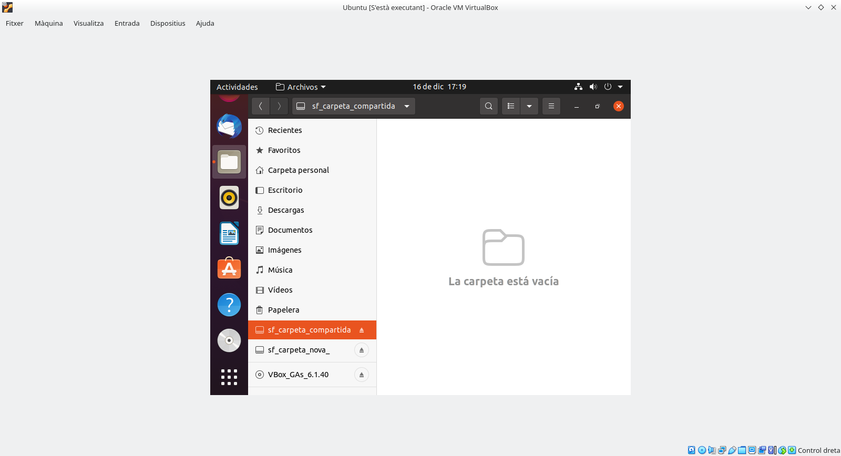

1. Export and import a virtual machine. What is the extension of the file created when exporting?. Check if the new Virtual Machine works after importing it.

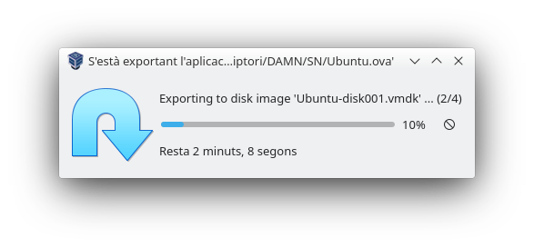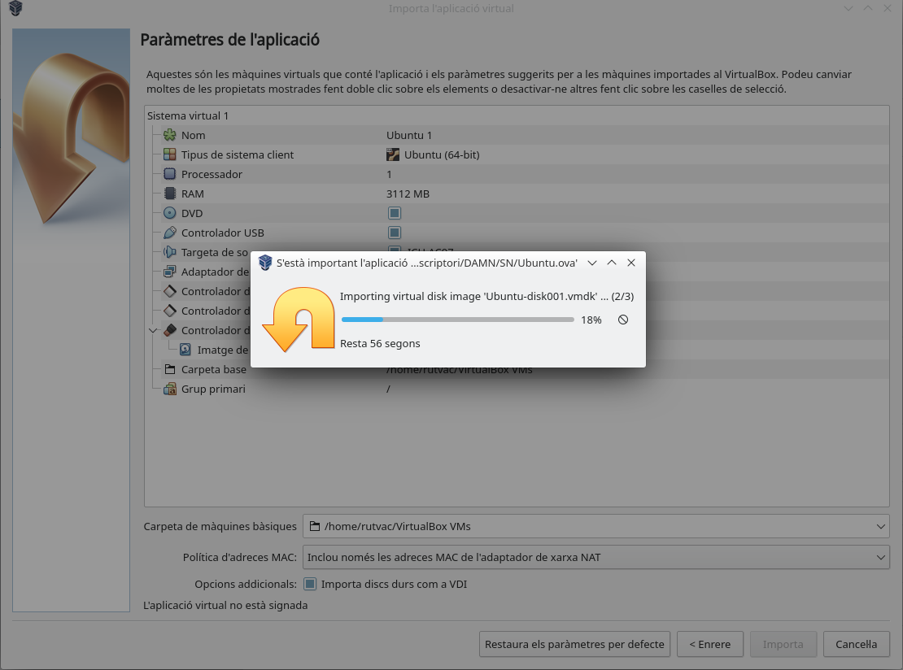

1. Storage in VirtualBox: Create a new hard drive with VDI format (2Gb), dynamic size. Add it to the your Virtual Machine. Format the new disk using Ubuntu “disks” application on your Guest Machine, give it an Ext4 file system.